Chapter 10

2.4 GHz channels overlap each other

SSS- single frequency

HUB- an access point that conforms to the IEEE 802.11b standard acts most closely to what other networking device

CSMA/CA- all of the 802.11 standard for wireless networking support which type of communication path sharing technology

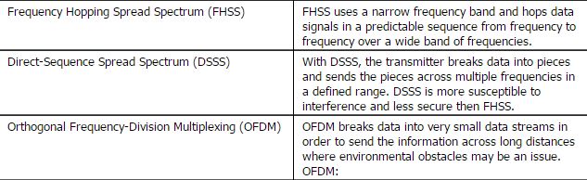

SSID- Group wireless devices together into the same logical network.

DS- wireless networking component is used to connect multiple APs together.

802.11

A- 5.75 GHz 150ft

B- 2.4 GHz 300ft

G- 2.4 GHz 300ft

N- (2.4 or 5.75 GHz) usually compatible with both 1200ft

802.11a, 802.11g- 54 Mbps

802.11ac- eight MIMO radio streams, 80 MHz bonded channels.

Wireless TV interfere messes with wireless.

802.11a- 5.75 GHz, 23 wireless networks

802.11g- 11 wireless networks

Wireless technology enables channel bonding

Same SSID, Different channels-to configure the access point.

Decrease the beacon interval- to create a small network

Configure a profile on the wireless client- security you disable SSID broadcast.

Preshared key, TKIP encryption- parameters to configure a laptop.

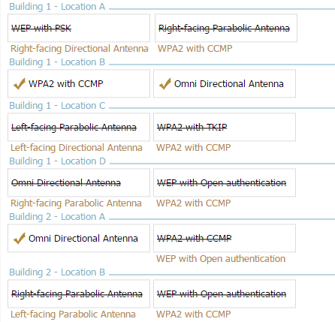

Multiple 802.11n access points that are configured as follows- Double the bandwidth assigned per channel to 40 MHZ

Purpose of wireless site survey serve- identifies the coverage area preferred placement of access points, to identify existing or potential sources of interference.

802.11n- 2.4GHz and 150mbps

802.11a and 802.11n- 54 Mbps and 2.4 GHZ

802.11n- 150 Mbps or faster

Design a SOHO environment- How many devices will need to be supported, what type of data will be transmitted on the network, and is the business expected to grow in size in the future.

Channel 1- 2.4 GHz

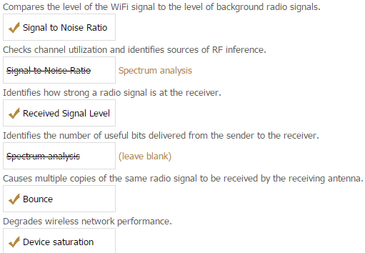

Guest WLAN for keeping public wireless traffic separate from private traffic- Distributed wireless mesh infrastructure.

